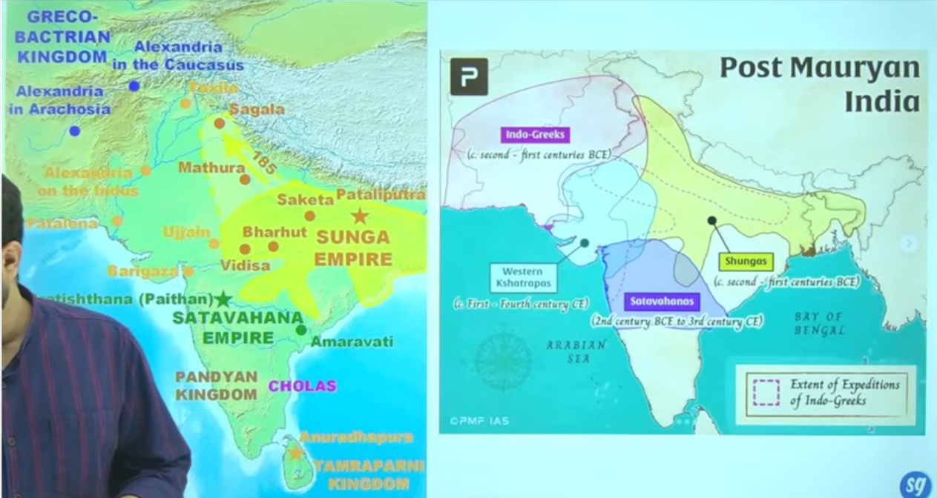

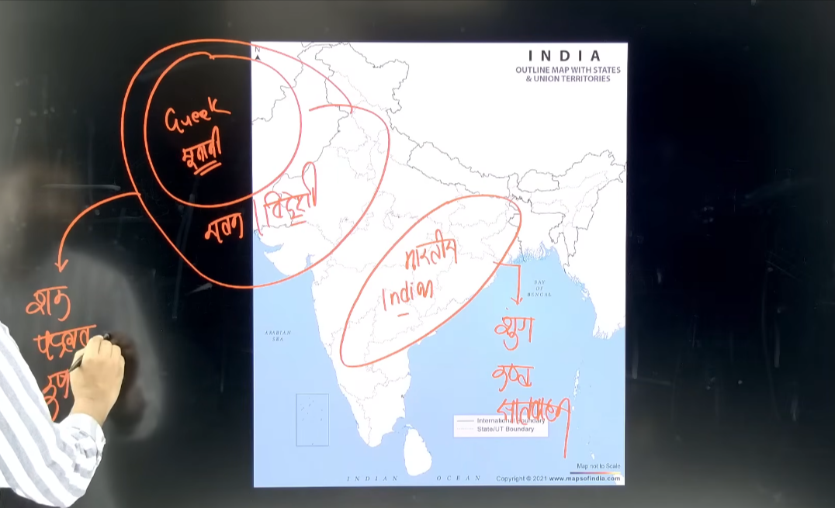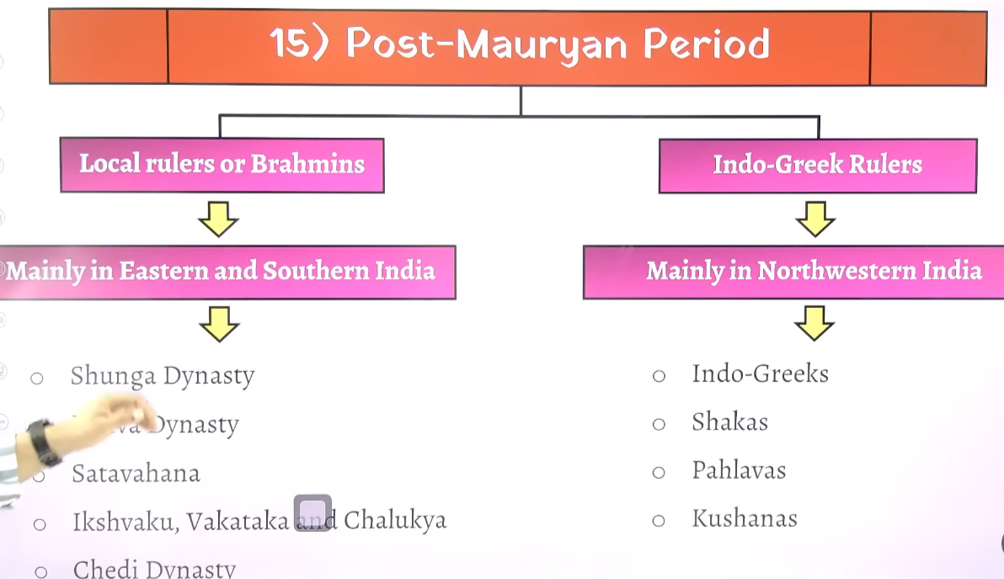

Bharytai rajyaon ko bhrahaman state ya brahman rajya bhe bola gayay hai post Mourant time me

History me aisa hota ke pahle chote chotestate ka formation hota hai fir ekbahut shakti shali vyakti ata hai aur in sabhe state ka jodakar ek bahut bada samrajya banta hai ek bahut bada empire banata hai fir uske succesero weak ho jata hai eaur fir ek baar fir se itna bada samrajya chote chote rajyo me tut jata hai ek he samay per kahe per a nameka rja hai kahe b name ka rja hai kahe c name ka rjah hai kahe d name ka raja to app dekhonge ke bahut sare dynasty ek sath dekhne ko milenge
Fir gupta ayenge gupta fir pure samrajy ko unite karnege fir gupto ka shashan khtm hoga fir chote chote bhago me shashan tutega fir delhi saltanta aege fir cheeze reunite hoge fir dlehi sultant ka vightan hoga fir Mughal anege fir muhgal unite karen fir mughalo ka khatma hoga
Sso on
Aaj bhe cheze apas me jude hai kuki hum democratic country hai republic country hai

Post mauryna time kek rrajao ko hum do bhago me bat kar padte hai
Ek hai indegeinous king bhatyia mul ke rajaj jo mukhya oop se east and south me shashan kar rahe the aur dusera hia indo Greek north west me the

Sathvahan ne 300-400 salo tk shaahsn kyia tha ye aisa pahla rajvansha tha jisne itne lambe samya tka shashan kyia tha mauryaon ne bhe itna lamba shashan nahi kyia tha unhion 200-250 varsh tk he sshashan kyia tha

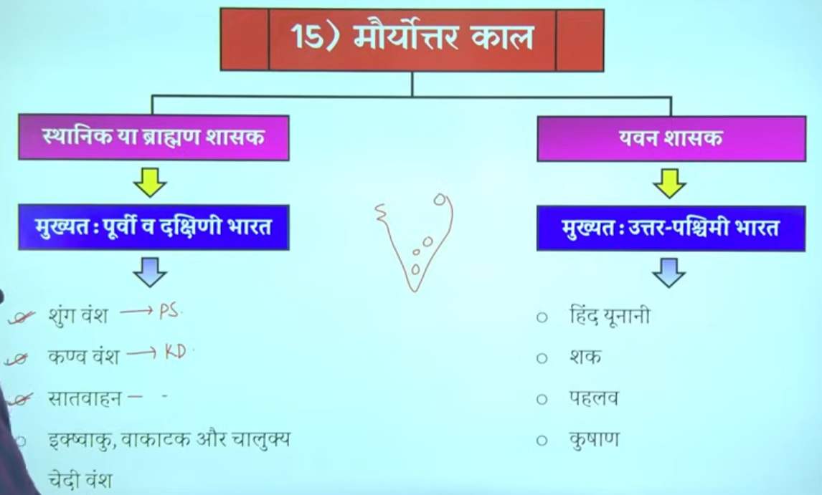

Bharat me ke post Mauryan time per east south me bhartyia mul ke rajah shashan kar rahe the to isse samay per paralleel north -west inda me indo Greek ruler rule kar rahe the
Sahaka are cythina isme jo shaka hai inhone bharat me 5 alag alag shakhao me shashan kyia tha jinhe chatrap kahah jat ahai
Bharat me shtrap pradali ko lane ka Shreya persian ko dyia jata ahi vishes taur per daraius first ko but shako ne usko bade paimaine per use kyia tha
Bhata me Mauryan kaal ka jb patan hua tha bharat ka sabse bada samrajya bhart ke chote chote samrajyo frangment state me bhatt gyaya tha

Where as the central and north west of india ruled by Greek ruler sucha as indo Greek cythian, parthiyan kushans
Whae Madhya aur uttar prachicm bharat me unanan ya Greek ruler ne shahsan kyia tha

Shunga ke captioa the patliputra nad vidhisha

Sathvahan ke ek capital prathesthan aur dusre Amravati the
Shaka 5 alag alag shakao me bharat me the to unko strhrap bola gaya hai

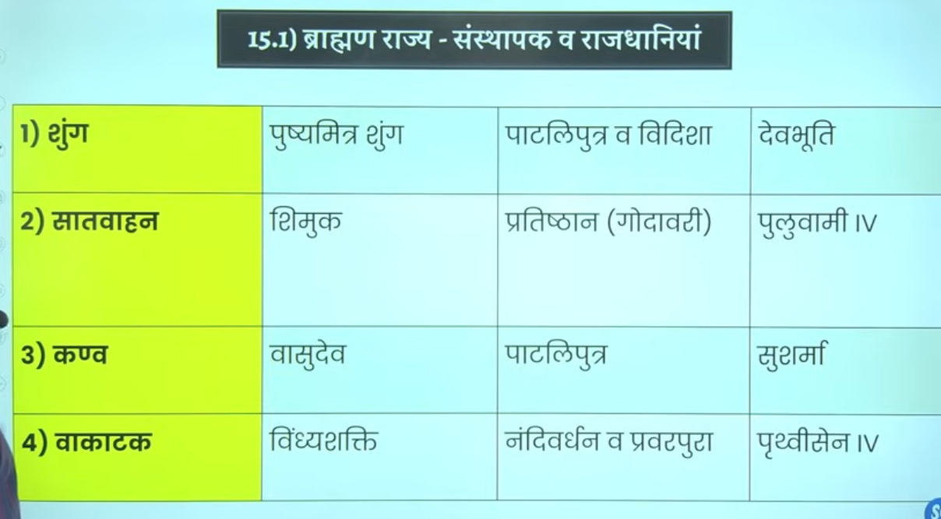

Shunga dynasty me ke do he mahahn shashak hue hai
Shunga dynasty magadh and mp wale region me rule kar rahe the

Ek to pushmitra shung jfounder
And dusra agnimitra
Isley famous hue kuki mahavkavi kalidas ne ek natak likha malivakimitra jisme Malvika aur agnimtria ke kahani ko vistar se discuss kyia tgaya hia

Post maury KE BAAD jitne bhe ruler ingeginous ruler aye inhone vedic dharma ka palan kyia hai ye sabhe vedic dharma ke follower the iska matlab ye nahi hai ki inhone dusre dhamr ka samaan nahi kyai
Isley is kaal ko brahman rajya bhe kaha jata ahi aur ye wo kaal hai jisme ye dobara se vedic dharma ko punaristhapti karenge ye vedic regliigon ko ek parakar se fir se reinvednte karenge india me vedic relgion ke buraee ko door karte hue jb rking is dhamko kao apnayega to praja bhe in dhara se jood jayege to yahe karana hai inhe brahman rajya bhe kahah jata hai

Padini ne inhie Bhardwaj gotra ka brahman batya kalidas ne Kashyap gota ka inke ancestor mp ujjan ke the

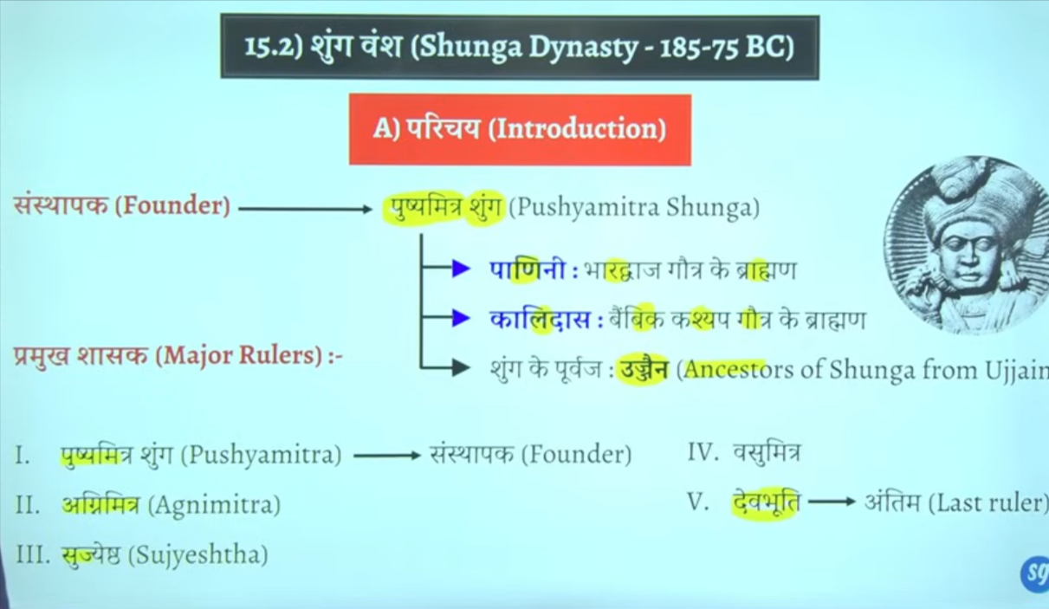

Isme teen he naam yad rako pusyhaita shunga agnimitra vashumitra and devbhut
Inke Rajdhani patliputra dn veidhisa
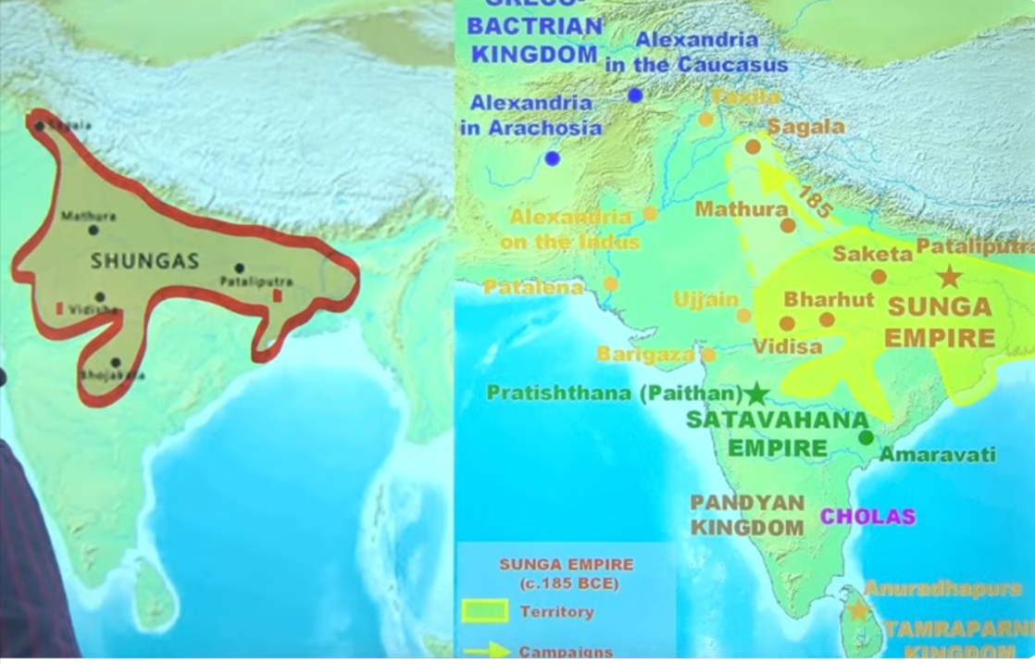

Pushay mitra shunga is the founder of Mauryan dynasty

Na sir shungo ne balki sathvahhano ne bhe isee tarah ke title upadhi ka proyog kyai tha jayega kuki ye sabhe vedic dharm brahman dharm ko matne the inke shashan kaal me inhone pure koshisk ke hai ke vedic dhamr ke punas ishtapana kar de jaye

Even you can see tha t pushyamitra shung ke purohit ka naam Patanjali tha
Ptanjali jinhone astadhayee per mahabhays ke rachna ke hai inke purohit ptanjali ne inse do bar ashwamedh yugyaa karwaas ytha
Ashwvmedh yaygay ko yagyo ka rajaj kahah jata hai ye sabse abadda yagya tha jo rajnatiek vistar aur samprabhuta ko dekhata tha jo political expansion and sovernity ko dekhata tha ek horse jaha jahah jjata wo sara Chetra us rajya ke antargat aa jata tha is yagaya ke baad samnyata wo raja Chakravarti samrat ke naam se jana jat a tha
Ye yaad Rakha ke hau ku ise vedic purnarjagran ka kaal bol rahe hai

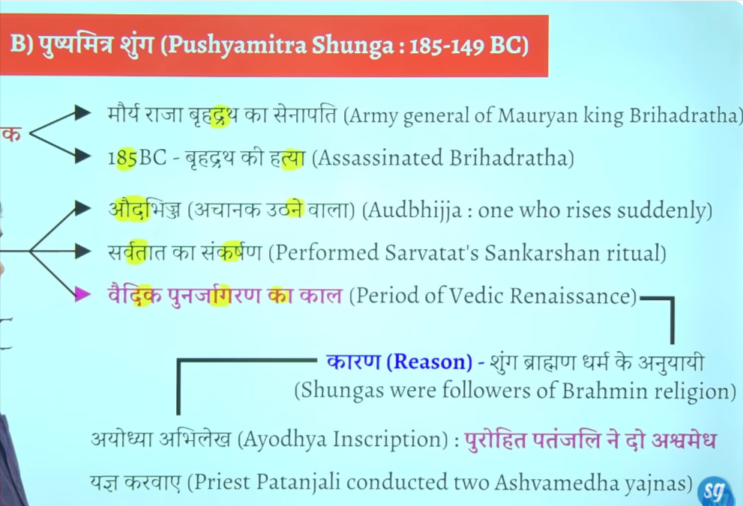

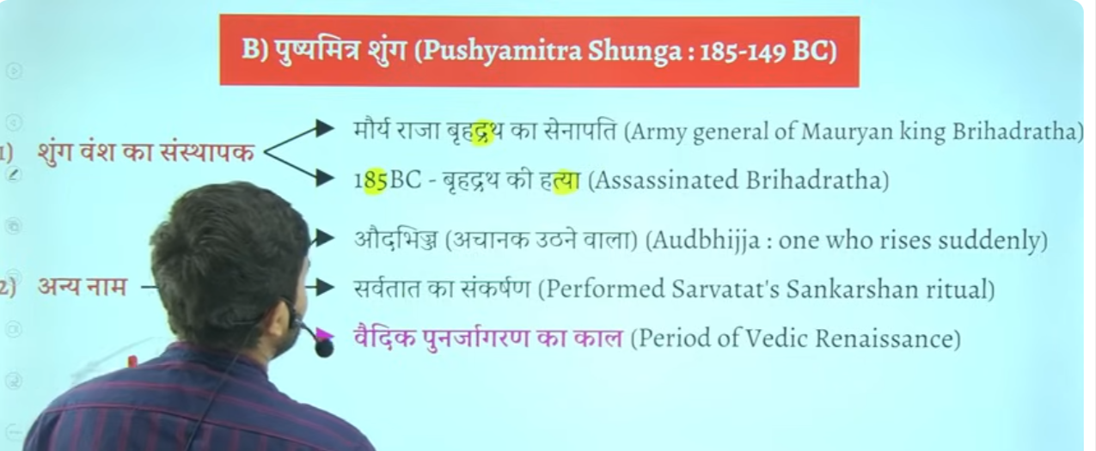

Pushyamitra shunga ne hind unane indo Greek ruler minander ko defeat kyia tha
Ye wahe menander hai jisne nagsen ke ssath ek vad vivad pratiyoga ke the phir unke question answer pe ek book likhe kage the milindpanho ye wahe menander Milind hai
Book name minlindapahno Milind ke question
Sanchi ke stoop ke railing mitti kie bane the isne usko stone ka bnwaw tha
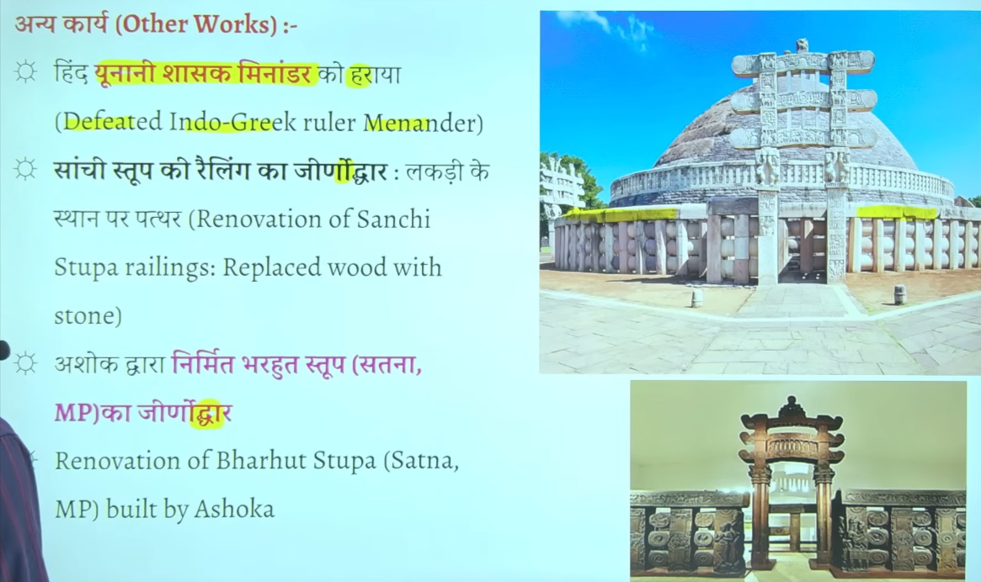

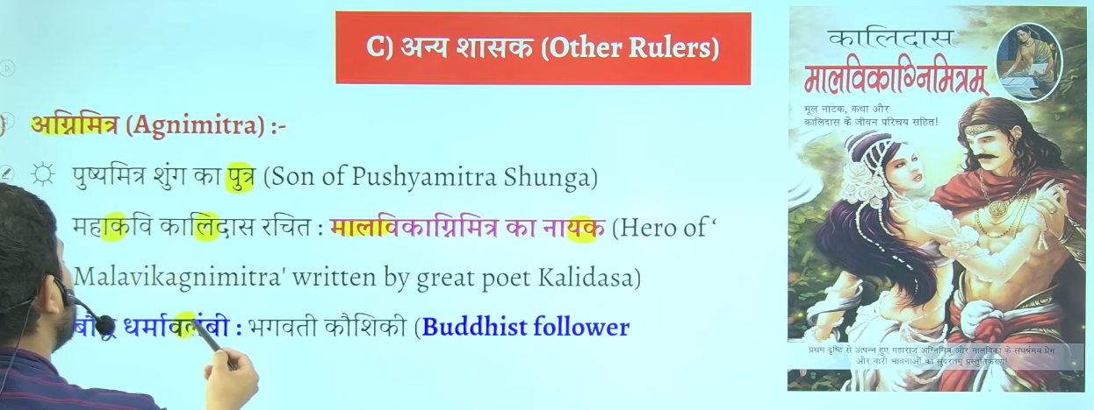
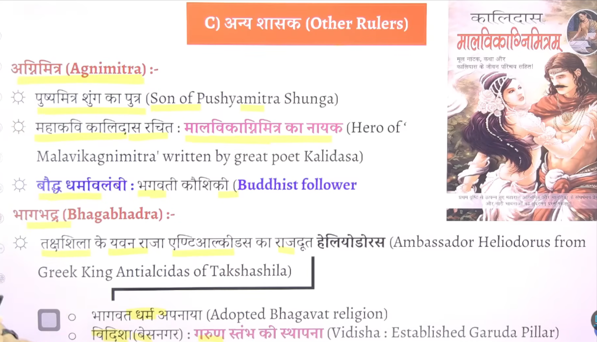

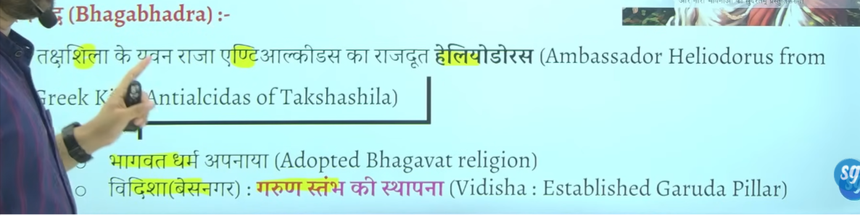

Bhagbhadra ke sahashan kaal me taksheeela ke ingogreek ruler antialciadas ke ambesador heliodoruosu inke shahsan kaal me ayay tha Vidisha ayaa tha
Jo ke bhavgvat dharm se influence hokar bhagvat dharm ko apnaya tha
Vidisha jisee base nagar kaaha jaat ahai inse wahah garin ishtam ko establish kyia tha

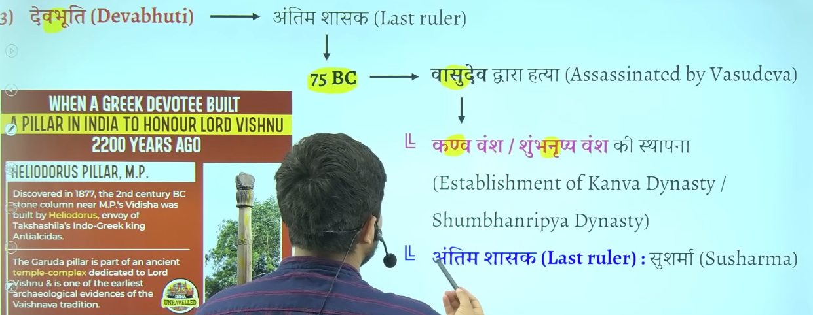

Kanva vansha j 10 20 saal he chaal kanva ka antim ruler shusharma hua jisko marka ke simuk ne sathvahan dynasty establish kyia tha

🟡 Shunga Dynasty – Rulers (with time)
- ⭐ Pushyamitra Shunga (c. 185–149 BCE)
- ⭐ Agnimitra (c. 149–141 BCE)
- Vasumitra (c. 141–131 BCE)
- Bhadraka (c. 131–124 BCE)
- Pulindaka (c. 124–122 BCE)
- Ghosha (c. 122–114 BCE)
- Vajramitra (c. 114–82 BCE)
- ⭐ Bhagabhadra (c. 82–75 BCE)
- ⭐ Devabhuti (c. 75–73 BCE)

🔥 Important yaad rakho:
👉 ⭐ = Exam me zyada puchhe jaate hain
👉 Start: Pushyamitra
👉 End: Devabhuti

Kanva dynasty

🟡 Kanva Dynasty – Rulers (with time)
- ⭐ Vasudeva Kanva (c. 73–64 BCE)
- Bhumimitra (c. 64–50 BCE)
- Narayana (c. 50–38 BCE)
- ⭐ Susarman (c. 38–28 BCE)

🔥 Important yaad rakho:
👉 ⭐ = Exam ke liye important
👉 Start: Vasudeva Kanva
👉 End: Susarman
👉 Total kings: 4 hi the (easy yaad 😄)

Agar chaho to next mai Satavahana dynasty bhi isi format me bana deta hoon 👍

🟡 Kanva Dynasty – Important Notes
⭐ 1. Founder
👉 Vasudeva Kanva
👉 Shunga ke last king Devabhuti ko maar kar rule start kiya

⭐ 2. Time Period
👉 c. 73 BCE – 28 BCE
👉 Bahut short-lived dynasty thi

⭐ 3. Capital
👉 Pataliputra (present Bihar)

⭐ 4. Total Rulers
👉 Sirf 4 kings the:
👉 Vasudeva → Bhumimitra → Narayana → Susarman

⭐ 5. Nature of Rule
👉 Weak aur short dynasty
👉 Mainly Magadh (North India) tak limited rule

⭐ 6. End of Dynasty
👉 Last king Susarman
👉 Isko Satavahana Dynasty ne hara diya

🧠 One-line Revision Trick:
👉 “Kanva = 4 kings + short rule + Satavahana ne khatam kiya”

Agar chaho to mai iska MCQ + revision chart bana deta hoon jo direct exam me help kare 👍
kanva ke bare me upsc ke lyei improtnat bate do
Bilkul 👍 UPSC ke liye high-yield points short aur crisp form me:

🟡 Kanva Dynasty – UPSC Important Points
⭐ 1. Origin / Establishment
👉 Founder: Vasudeva Kanva
👉 Last Shunga king Devabhuti ko hara kar power li

⭐ 2. Time Period
👉 c. 73 BCE – 28 BCE
👉 Very short-lived dynasty (≈45 years)

⭐ 3. Political Nature
👉 Brahmin dynasty (important for UPSC)
👉 Rule mainly Magadh region tak limited tha
👉 Strong central control nahi tha

⭐ 4. Capital
👉 Pataliputra

⭐ 5. Rulers (Order important)
👉 Vasudeva → Bhumimitra → Narayana → Susarman

⭐ 6. Decline / End
👉 Last ruler Susarman ko
👉 Satavahana Dynasty ne defeat kiya

⭐ 7. Historical Importance (UPSC angle)
👉 Shunga ke baad political instability ka phase
👉 North India weak hua → foreign invasions (Indo-Greek, Shaka etc.) ko mauka mila
👉 Parallel me Deccan me Satavahana rise hua

🧠 🔥 Super Revision Lines:
- 👉 “Kanva = Brahmin dynasty + 4 rulers + 73–28 BCE”
- 👉 “Shunga ke baad, Satavahana se pehle”
- 👉 “Weak rule in Magadh”

Agar chaho to mai Shunga vs Kanva vs Satavahana comparison bana deta hoon — UPSC me direct question aata hai 👍

Shunga dynasty

Ye gairchetryia shashak tha jati se brahman tha budha dharma ko sabse adhik nuksan pushyamitra shunga ne karway tha
Capital of shunga wans is vidhisa or patiliputra but main is mp me vidhisa ye patliputra se Rajdhani udhakar le gaya madhyapradesh kke vidhisa me
Ye buddha virohdi tha isme bahut sare buddha stupo ko nast karwa dyia tha but isne sanchi and barhut sitop ka punarnirman bhe Karwar tha

Usne bahut sare buddha stop ko tokar waha Sanskrit vidyaaly , mandir, ya gurukul jo use dekh laga usne wo banwaya tha jaha uskno nast karna thek laga usne nast karwa tha
Patanjali pushyamitra ke purohit the yani inke yaah jo bhe puja path hoga wo Patanjali karte the
Iske time per bahut sare granth likhe gae hai tojada tar granth pushyamitra ke time per he likhe gae hthe
Isne bahtu sare buddha vihar ka Nirman bhe karawa aur nast bhe kyai tha but jaydatar nast kyia tha
Ikse time per he buddhsit book jatak ka Nirman purja hua tha iske time per he Sanskrit book astadyaye ka Nirman hua tha iske timer per he manuistmiti likhe gae the

Astadyaee kisse sambhandit hai vyakarna se sambahndieth hai
Ye teeno pramukh book iske time per he likhe gae the

Gargi ne likha tha gargisamhita budah bikshuk ne likha jatak granth

Manusmirit bahut controversial book tha usme women and dalit ko uchit ishtan nahi dyai gaya hai

Jinsen ne harivasnh ke rachna ke to sabse Jayda book kiske tim per likhe gae to answer is pushymitr ashunga

Jb pushymitra shunga shanshn kar rahah tha tb magadh samrajya ka ant ho chuka tha cuki magadhsamrajya bahut he saktishali smarjay tha Ashoka bahut shaktishali tha uske succesoer bahtu weak the iska news agala bhagal ke Chetra me fail gayay tha jiske karan jo central asia and north west area ke indo Greek vedeshi rulers the unhone socha ke ku na magad per akraman kar de kuki magadh samrjaya to khtm ho chuka hai to fir Videsh se akraman hona fir se chalu ho gaya tha halaki apapa dehskte hai jb tk Mauryan dynasty the tb tk koi vedsehi akrmankari nahi ayaya tha
Chuki pushymitra shung ne bradhrth ko mara iske news pure bharat aur bharah bhe fail gae the to viedshi akrmankariyon ne socha ku na hum jakar pushymitra shung ko mar de

Pushymtir shung ke samay do vedhsie akramankari aye cuki wo madya asia central asia se aee the to unko yavan kahah jata tha
To pushmmitra suhung ke samay kitne akrman hue to do dono akraman yavan ne kyia tha aur pushyamitr ashunga ne dono ko hara dyia tha

Jaise isne harya iska varchasva bad gyay logo ne baola are bhaut shaktishali kiukisisne do vedehsi yvana akramankari ko parajeet kar dyai agal bagal me pushmita shung ke naam ka dahshat fail gaya tha
Pushmitra shung ne socha acha mauka hai patanjiali ko bulakar do ashvamedh yagay kar dyai
Chuki jb yavan akramankair ko harya tha to bharat ka chote mote raja aise he dar gaey the t o iske ashwamedh yagya ka horse ko chedna kisne ne ucht nahi samjha tha
Jitne bhar isne vedhesh ko harya utne baar isne aswmedh yagya karwaya tha
Do bar vedshi akrmankair aye aur dono bar shunga jeeta do aswamedh ygay karawa dono ke purohit the ptanjali

Pushyamitr ashung jeta tha apne beta ke wajah se iska bet atha agnimitra jo bhaut yogya tha yudh karke laut rahah tha aur ye fas gaya ek mahila ek prem me Malvika naam ke mahila the

